National Show Garden Visits Sun 19th - Mon 20th August 2018
Taranaki is well known for its lush landscapes, wonderful growing conditions, and beautiful gardens. It has also been the centre thriving nurseries for much of NZ’s European history, with a stream of quality field grown ornamental plants flowing out to stock garden centres nationwide. Camellias grow particularly well here, and it is no surprise that of the 469 new camellia varieties registered in NZ up to 2015, 131 of them, or 28%, originated in Taranaki.
Even though our branch hosted the National Show only three years ago, we have found an entirely new lot of gardens to visit, all diverse, and all having different aspects relating to the horticultural history, plant production, or plant breeding of our province.

Sandra and John Spence New Plymouth
Sandra and John have been passionate about cacti and succulents for much of their lives, and have been exporting plants to Asia for many years. Two poly houses at the rear of the section are overflowing with a fascinating collection of these weird and wonderful oddities of the plant kingdom…the diversity and variation is quite amazing.
The garden also features a large, eye-catching selection of bromeliads, happily growing on raised beds with a backdrop of camellias. Sandra has recently become interested in potting, and examples of her work add colourful ornamentation among the plants.
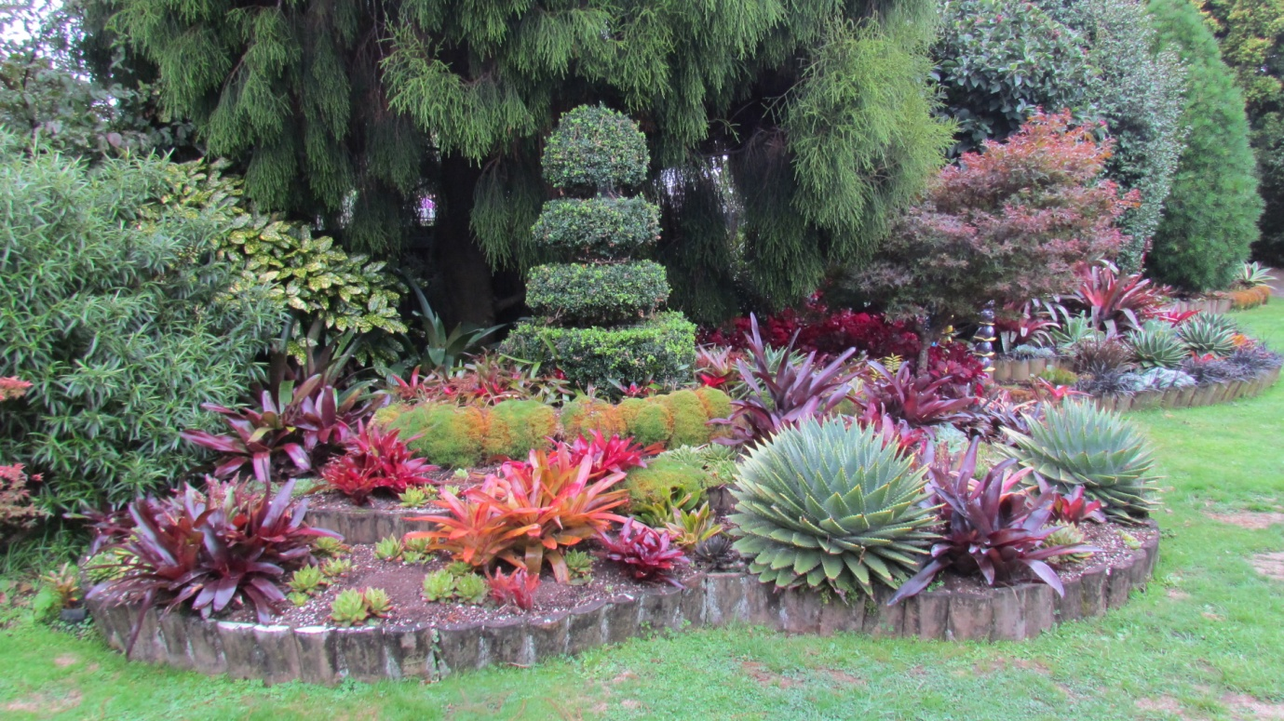

Lynn and Robyn Bublitz New Plymouth.
Well known and respected throughout NZ in horticultural circles, Lynn is a plantsman to the core and has been Chairman of Pukeiti Trust for many years. Although a secondary school teacher and principal by career, he studied botany at university, and plants (and local politics!) have always featured largely in his life. While not large, Lynn and Robyn’s garden, established over 45 years, is very, very full. Nestled in a sunny, sheltered hollow, sloping down to virgin bush in the valley floor, it provides diverse conditions for a wide range of rare and special plants, and a quiet retreat from the owners’ very busy life.
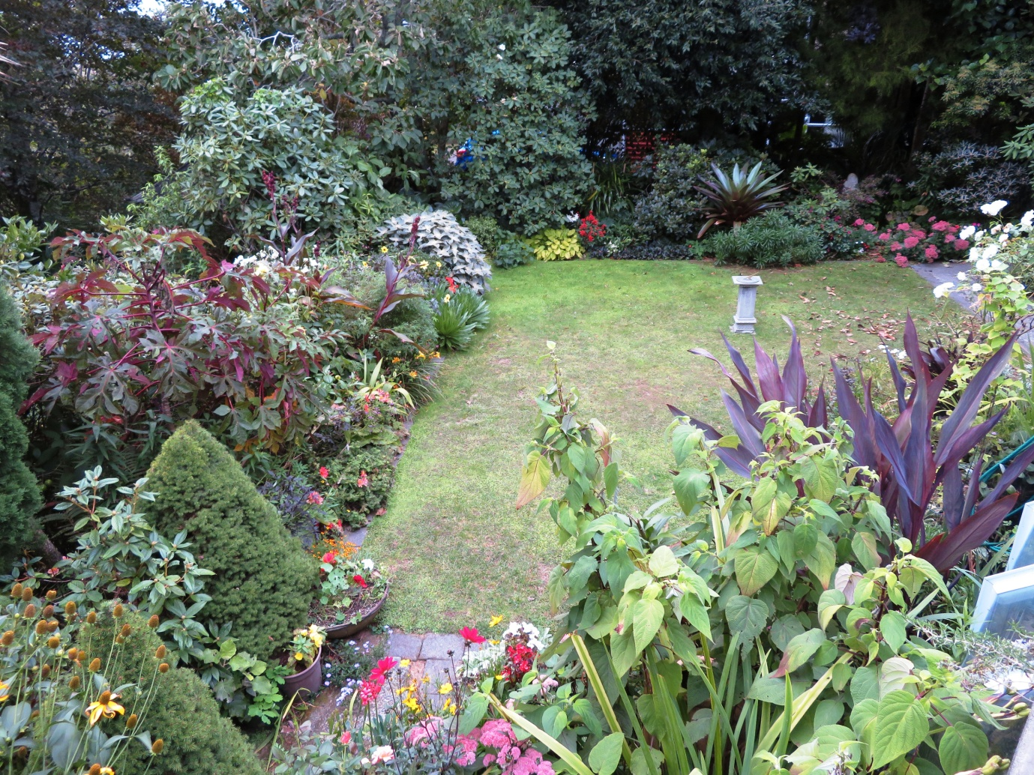

‘Villa Heights’ John and Rosemary Lucas Lepperton
Almost 20 years ago John and Rosemary moved a classic villa from South Taranaki onto an exposed windy ridge of their farm, and since retiring from milking have been operating a successful bed and breakfast business. Establishing a garden was not easy, but now the trees provide shelter and almost block out the wonderful views over the lush Taranaki countryside, down to New Plymouth and out to sea. The garden is formal near the house, and becomes more relaxed and easy care in the outer reaches.
The property has just been put on the market, and if it sells before our show date we will wish John and Rosemary all the best, and arrange an alternative garden to visit.
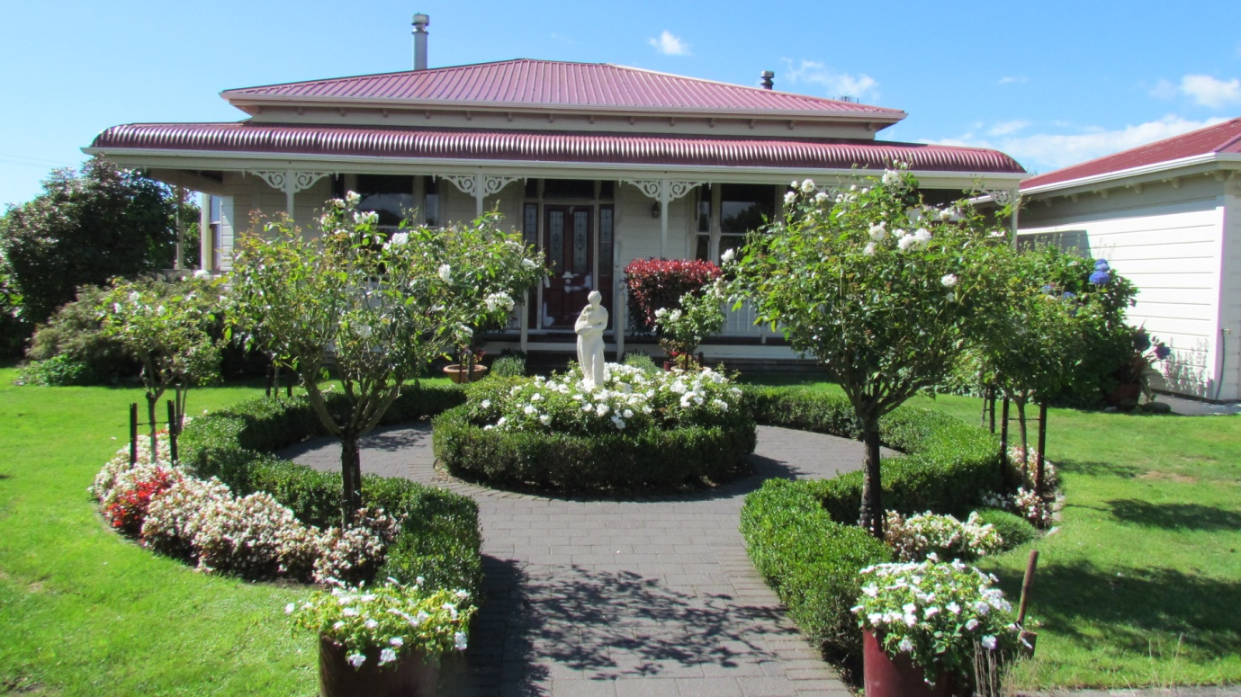

Pauline and Tony Zieltjes Lepperton
Pauline and Tony have owned their 15 acres of marginal farmland for almost 30 years, originally farming Angora goats in their spare time. After the goats went, a garden was started, with the primary aim of attracting birds and bees. It was never intended to be a formal garden, but rather rambles around the homestead spreading down the slopes. Pauline’s father Des Crowley encouraged the planting of camellias, often arriving with a few new ones to plant, so that there are now almost 400 .
The garden continues to evolve, and now that Pauline and Tony are retired, is getting more attention. Five acres of virgin bush at the bottom of the property provide a nursery of seedlings, which are gradually being transplanted, extending the perimeters, so that a 10 acre block of established and regenerating bush can be covenanted with the QE11 Trust for a future reserve.
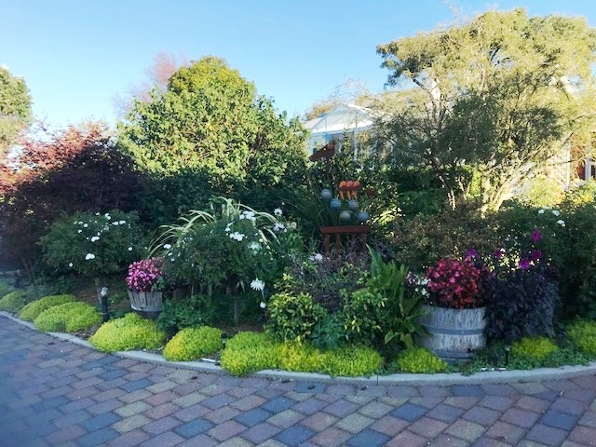

Jim Rumbal Waitara
Another well known NZ plantsman, Jim worked for almost 50 years in research and development with Duncan and Davies Nurseries, and as such has been instrumental in importing, selecting and introducing a wide range of ornamental plants into NZ.
Especially interested in dwarf Chamaecyparis conifers, his large, well established garden contains probably the best collection of these in the country, many species and hybrid camellias, plus lots of other rarities. From a vantage point at the rear of the garden is a wonderful view of the Waitara Valley
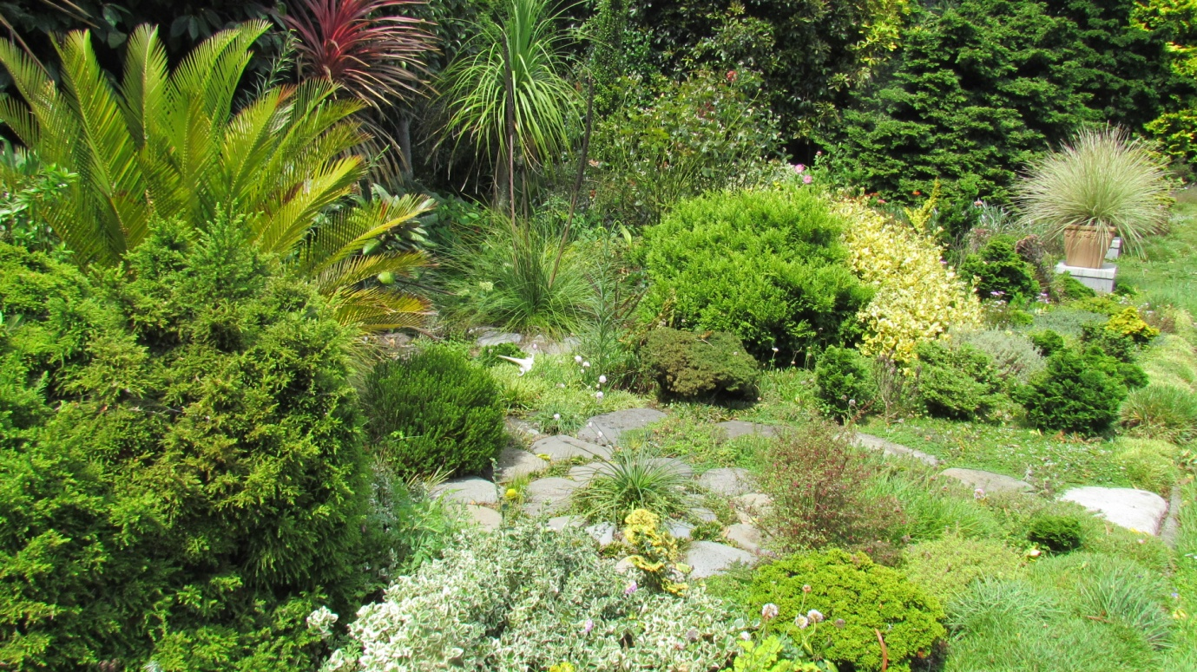

‘Puke Awa’ Graeme and Robyn Lepper Lepperton
Graeme’s great, great grandfather took up land grants here in the late 1860s and the property has been in the Lepper family ever since, with the current house built in the mid 1890s. Graeme’s mother Pauline was an avid and very talented gardener, and she and her husband Denis extended the garden substantially in the 1970s and 80s.
Sweeping lawns, wide borders, and established trees provide a perfect setting for the family homestead. Graeme and Robyn now care for the garden, and have done much work trimming and rejuvenating parts of it. Although several 100+ yr old trees have had to be removed in recent years, the charm and peace of the garden remains.
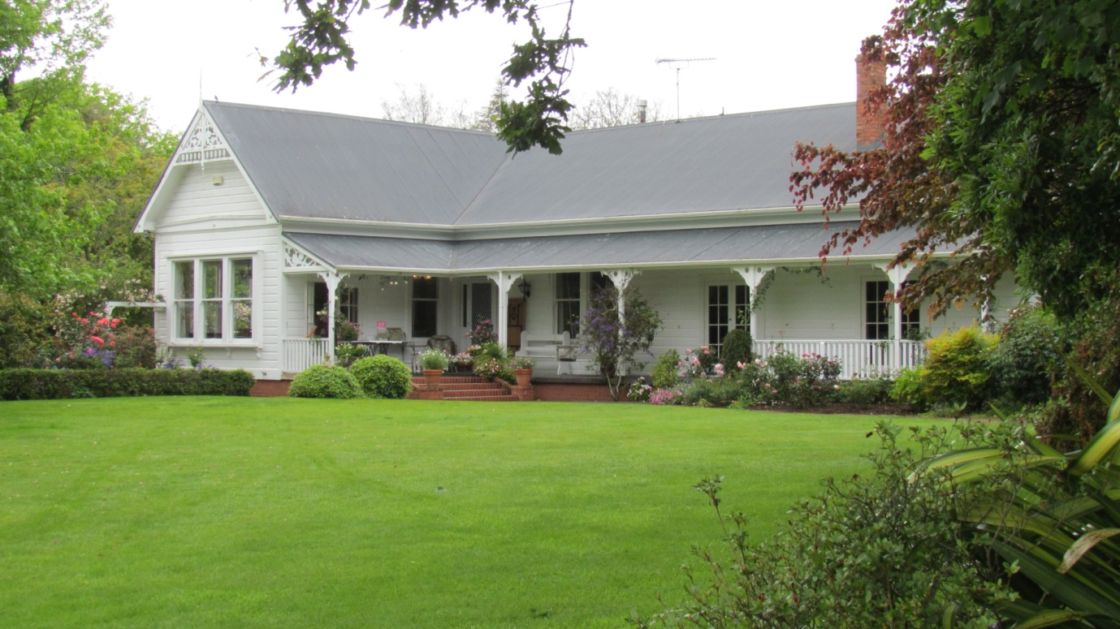
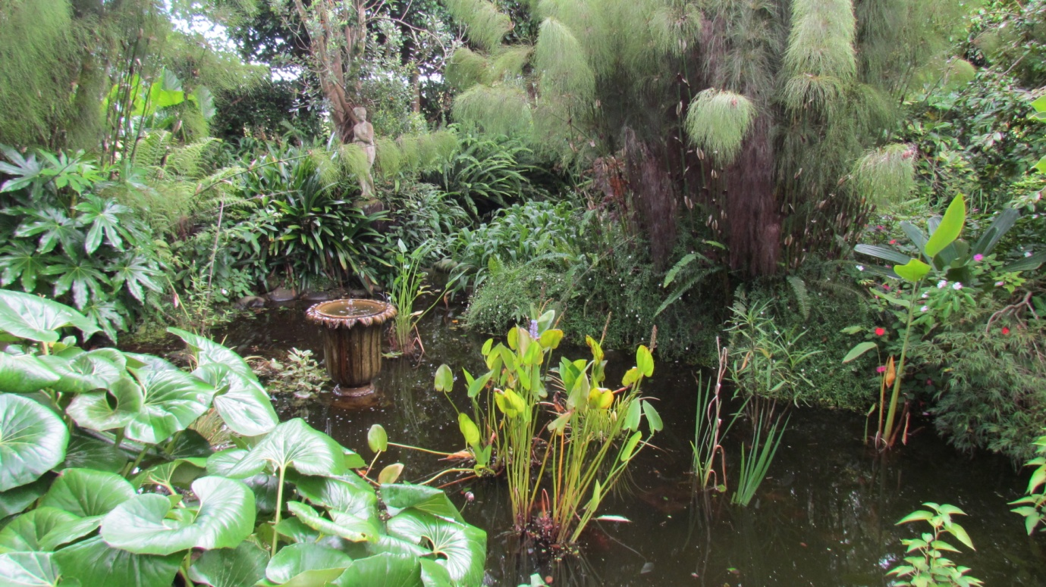

Te Henui Cemetery Lemon Street New Plymouth
As the settlement of New Plymouth grew, the traditional church graveyard around St Mary’s Church filled, and a new cemetery on the outskirts of the town was gazetted. The first burials took place at the Te Henui cemetery in 1860, with separate areas designated for Anglicans, Methodists and Presbyterians, Catholics, and Servicemen.
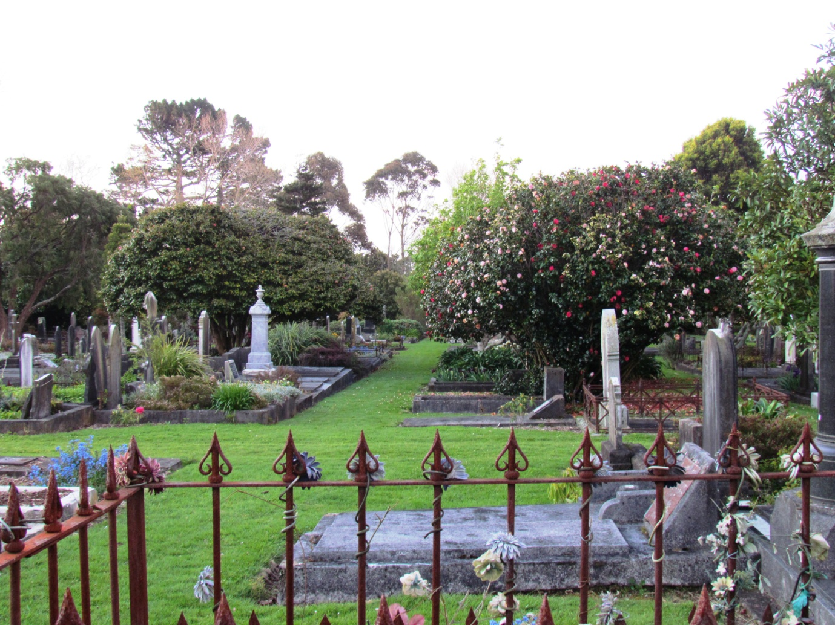
There are several old camellias here, planted in the 1880s and 1890s, and extensive plantings were made in the 1970s and 1980s with popular varieties of the time donated by the North Taranaki Branch of NZCS. Sadly, most of these were removed totally by the NP Council about 5 years ago, without our knowledge or consultation. However, the adjacent Te Henui Walkway, alongside the river, and the cemetery boundary in the Returned Services area, contain about 300 varieties planted on Arbour Days during the 1970s. We will not have time to see these, but the historic oldest part of the cemetery is now cared for by a group of volunteers, who have created a beautiful park like effect, by planting a series of miniature gardens on many of the old graves.
It might seem strange visiting an old cemetery, but it is well worth it.

Lowlands Nursery Waitara
One of the leading propagation nurseries of hardy ornamental trees and shrubs in NZ, it was established by owners Ian and Robyn Fankhauser in 1990, when Ian left Duncan and Davies Nursery, where he had been managing the propagation department. Producing over 600,000 plants annually, these are purchased and grown on to saleable size by nurserymen from all over NZ.
Camellias have always been a prominent part of Ian’s range of product, and after Duncan and Davies stopped exporting, Ian supplied tens of thousands annually to overseas customers. He has extensive mother beds to supply cuttings and still grows about 25,000 each year. Ian has been growing a range of varieties that are seldom available for our North Taranaki Branch to sell as fundraisers at this year’s National Show (see page….)
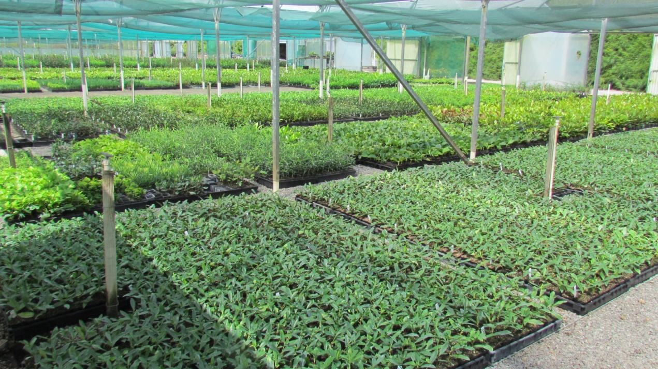

‘Tikorangi’ Mark and Abbie Jury Tikorangi
The Jury family have lived, farmed and gardened here since 1880, and their name has become almost synonymous with gardening and plant breeding. The garden and park, largely established by Felix and Mimosa from the 1950s contains possibly the most comprehensive collection of plants of any private garden in NZ, and while Mark continues to follow in Felix’s footsteps, hybridising magnolias, camellias and other plants that take his fancy, Abbie has earned a respected name as a garden writer.
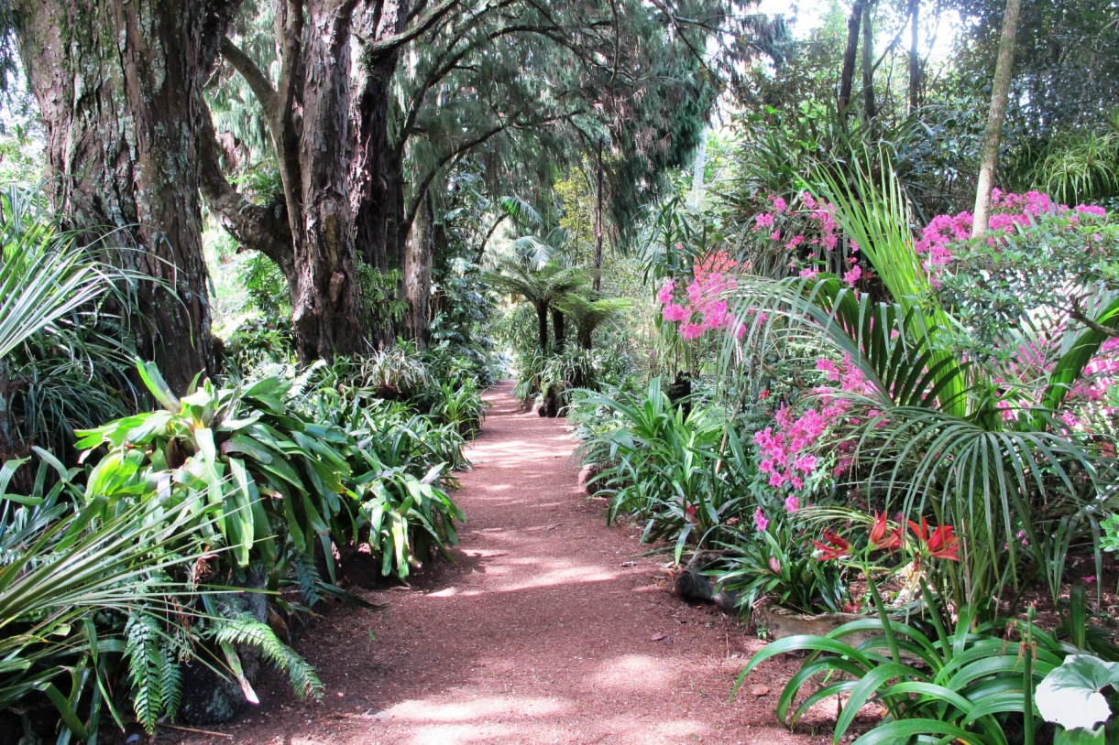
While no longer growing plants to sell, the garden is maintained to a very high standard, and the old nursery site is currently being redeveloped. There should be many camellias and magnolias blooming for our visit, and the rock garden, full of bulbs and other treasures, will also be colourful with flowers.
