GROWING and SHOWING CAMELLIAS
By Harvey Howard
Introduction 1
Part One: Growing 2
Buying a Camellia Tree 2
Ground Planting 2
Planting in a Pot 3
Fertilising 3
Spraying 3
Pruning 4
Watering 5
Useful Tips 5
Part Two: Showing 6
Entering your Blooms into a Show 6
Picking, Boxing and Traveling Your Blooms to a Show 6
Prepare the Packaging Area 7
What to Look for in a Show Bloom 7
Pick Your Blooms 8
Putting Blooms in Pottles 8
Preparing Blooms to Travel 8
Benching Your Blooms 9
Useful Tips 10

Introduction
Welcome to my camellia world. Having had continued success with showing this amazing flower at branch and national levels, I have been asked by the NZ Camellia Board to give my thoughts on the growing and showing of camellias so as to assist our new members, our not so new members and anybody perusing our website for information.
The last publication, Growing Better Camellias in the 1990s (which is no longer available), covered everything to do with the growing of camellias in New Zealand, and a little on showing. I believe this bulletin still has all the facts required, but it is outdated.
My intention is to give up-to-date ideas, which will be intentionally aimed at the beginner in our society. With showing, I am well aware that there are members out there who want to show, but who do not know the procedures, as well as other members who will not attempt showing, because they don’t have enough information to do so. Maybe the following will help.
However, before we go any further, there are—in my opinion—two publications that anybody who wishes to grow and show camellias needs to have to identify flowers, which after all is the end product of growing camellias in the first place:
- The Camellia Nomenclature, put out every three years by the Southern California Camellia Society. New members, ask your branch secretary for information on gaining this publication.
- Camellias: A Photo Dictionary, by Don Ellison. This book has photos of over 1,000 camellias and I believe goes hand in glove with the Camellia Nomenclature for carrying out easy identification of blooms. A good bookshop should be able to get a copy for the beginner, or try Trade Me.
The rest of the information that I am giving will be split into two parts, Part One covering growing and Part Two covering showing.

Part One: Growing

Buying a Camellia Tree
Although there are 270 plus species of camellia that have been found and tabulated from the wild, in New Zealand we only use four species in their various forms. They are the:
- Japonica
- Hybrids of the japonica that have been crossed with species other than the reticulata
- Reticulata, and its hybrids
- Sasanqua, an autumn flowering tree, which is not used for showing.
I know the above categories sound confusing, but by looking at your Camellia Nomenclature, things will fall into place. If not, ask. There are a lot of camellia-minded people more than willing to help in our society.
Now that we know the three different species (japonica, hybrids reticulata,) we are looking to buy when starting a camellia collection, we now need to know where to go to buy these trees.
Firstly, try the likes of MegaMitre10, Bunnings, or your local nurseries. Be sure to only buy your trees when they are in flower, so that you know you are buying the tree that you want.
Alternatively, you can buy from specialist nurseries that sell at wholesale rates. The price per tree is very good, but you need to buy 25 trees to get the wholesale rate. If you have a couple of friends wanting trees at the same time, this is the way to go. Otherwise, wholesale nurseries will still sell single trees, but at retail rates. For North Island people try Cambrian Nurseries in the Waikato, for South Island people try Thirkettle Nurseries in Nelson. I have used this nursery for years. They also have a very good website.

Ground Planting
Now that we have some trees to plant, the first question to ask is, where is the best place on our property for this? The rule of thumb is, always put a japonica or hybrid on the south side of a solid fence or the house. Japonicas and hybrids do not tolerate full sun in New Zealand and the leaves can get sunburnt. The reticulata is a little different and will tolerate early morning or late afternoon sun.
Without exception, camellias planted in the ground need very good drainage. More trees die from root rot (photopfora) because their roots are in water, than from any other cause.
With this in mind, when you come to plant, dig your hole twice as big as the plastic bag/container that the tree came in. Then, backfill with a lime-free soil/compost mix, so that when you have removed the tree from its container, teased the roots out and placed it in the hole, the base of the trunk going in to the root ball is about two centimetres above the rim of the hole. I also put Osmocote in the bottom of the hole before the root ball goes in. Next, firm up the fill and root ball, ensuring that the trunk remains above the rim of the hole. Then, stake the tree (use nylon coated metal stakes) and gently water the complete area of the hole and its surrounds for at least a minute. Finally, tag your camellia with its name.

Planting in a Pot
Camellias grow very well in pots: in fact, I have over 60 trees in pots in a shade house – what a wonderful sight when they are all in bloom!
Planting the same tree into a pot is not so different. The only difference is that you need to pay a little more attention to your planting medium, and also consider the size of the pots you are using. Begin with a 15 litre pot for the first planting, then three years later repot to 30 litres and then after another three years, repot to 50 litres.
I am lucky in Marlborough in that I can purchase a low lime potting mix. My growing medium mix is:
- Three x 20 litre buckets of low lime potting mix
- One 20 litre bucket of medium pumice
- Two small handfuls of dolomite lime
- 10 tablespoons of Osmocote
Mix all together in a wheelbarrow.
Take your pot and cover the bottom holes with medium bark, then add sufficient mix over the bark, tamping it down so that when the teased out tree ball is placed in the pot, the base of the trunk is about three centimetres below the rim of the pot. Put in the rest of the mix so that the level is the same as the top of the tree ball. Use a nylon coated metal stake, tie off and then gently water the pot until waters comes out the base holes. Don’t forget to tag your camellia with its name!

Fertilising
I only use Osmocote as a fertiliser, whether planting a camellia in the ground or in a pot. Bagged fertiliser will kill a tree in a pot, due to the build up of salts in the mix. I have also found that bagged fertiliser on small trees in the ground does the same thing. The first indication that things are not going well is when the tips of the leaves begin to brown, and then the sides, before the leaves fall off the tree completely.
The only other fertiliser I use is Kinpack Sheep Powder. This is mainly a mulch, but it also has all the natural trace elements, which I think helps the growth of both the tree and also the flowers. I get Kinpack from MegaMitre10 and my local garden centre. It is a weed free product.

Spraying
There are three pests that affect camellia trees in New Zealand. In order they are the leaf roller caterpillar, black aphids and scale. All three can be controlled by Confidor, mixed with Conqueror oil. I use no other sprays. Spray in the early morning when it is not windy. Always, repeat always, use spray protection gear when you are working with toxic sprays. In fact, I always have a shower and change my clothing after I finish spraying.

Pruning
Last, but not least with growing camellias, is how to prune a tree. Some of the reasons for pruning are healthier camellias, better shaped camellias and also keeping a tree to a manageable size.
Two metres is probably the best height for a home garden. At that height, a tree can be easily cared for from top to bottom and the top blooms can be seen and reached.
You can prune lightly at any time of the year but finish the main pruning before the new spring growth has begun. This will ensure that all the nutrition supplied through the roots is being used by branches and foliage that you want left on the tree. Remember this year’s new growth will carry next year’s blooms. You cannot kill a camellia tree by pruning, as long as you prune before the start of the new spring growth.
When facing a camellia that has not been pruned for several years, during pruning demonstrations, the inevitable question I am asked is ”Where do I start?” This is a dilemma for most people when confronted with a camellia tree that has become a mass of tangled branches, dead wood and thick foliage. The answer is simply:
- Decide how high you want the tree and cut off everything above that height.
- Force your way into the centre of the three and remove dead wood, spindly and crossing over branches, so that when you are finished the centre of the tree is open to light. A camellia tree needs light and air moving in the centre to improve its general health and to help keep away thrip, scale and other undesirable pests and diseases that flourish in dim, damp conditions.
- Shorten back lateral branches to a growth bud pointed in the right direction
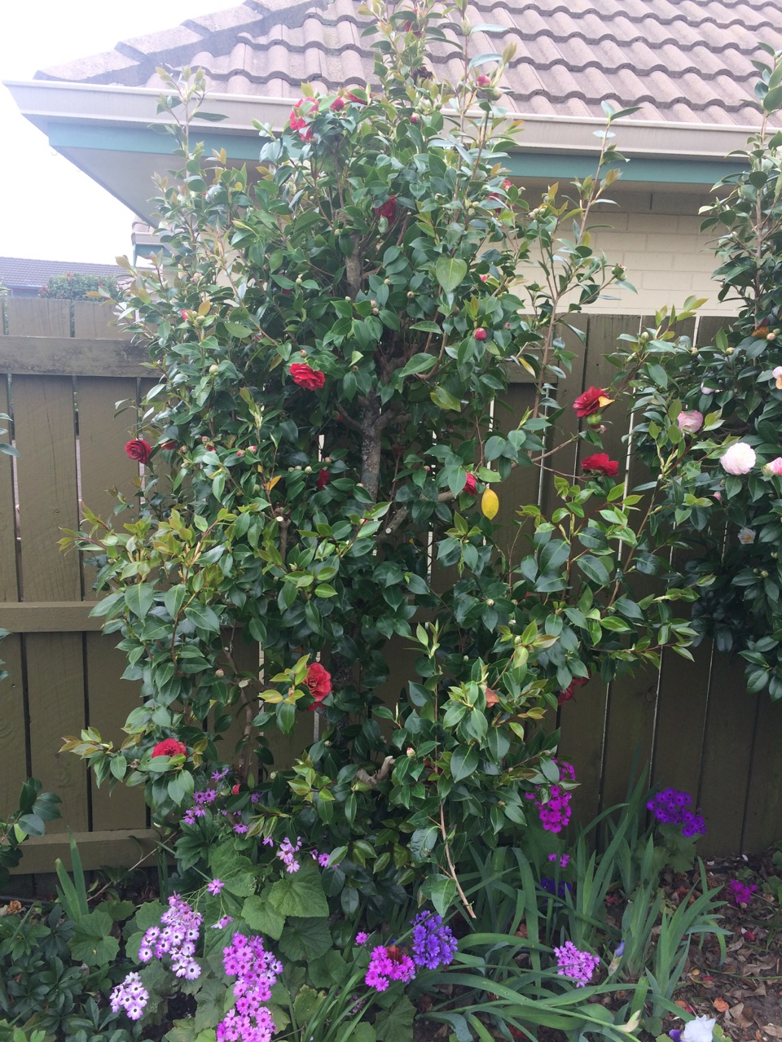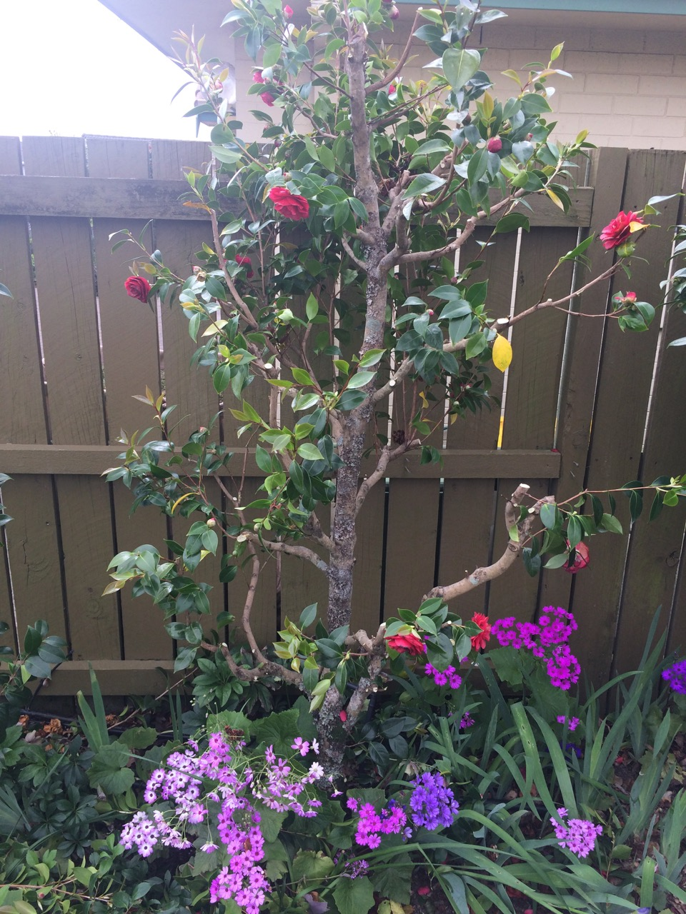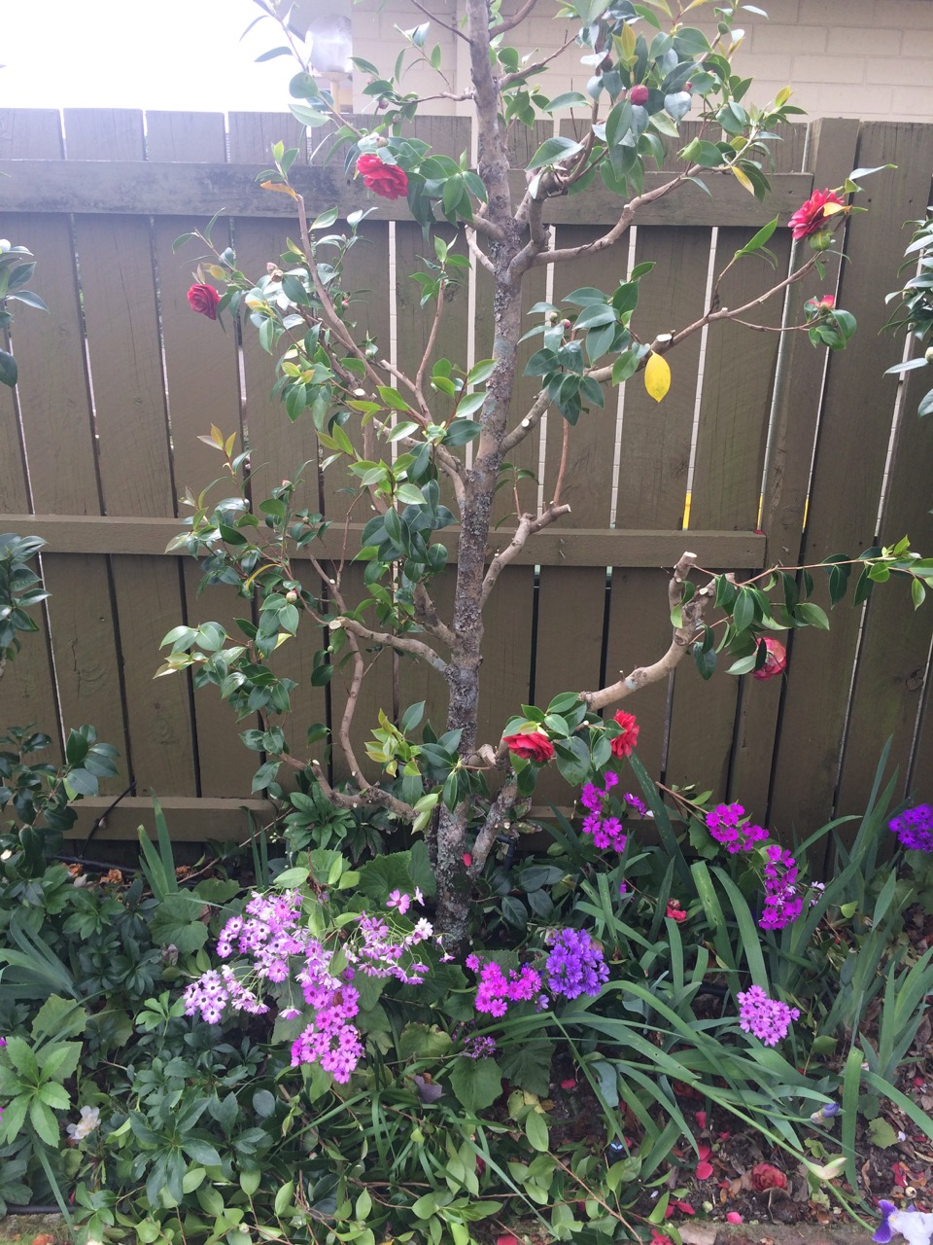
In the end, you should be left with a tree that is what you want with regards to height and width. Always prune with confidence. You will not harm your tree whether you prune lightly or ruthlessly. Remember, it is your camellia: its appearance should please you.
Finally, after pruning, I give my trees a treat and fertilise them all with the following:
- For trees in the ground, lightly tilth the soil around the drip line and apply Osmocote as per the directions on the Osmocote container. Secondly, apply dolomite lime (not ordinary lime, as this will kill the tree) to a ration of one tablespoon for trees under one metre in height, and two tablespoons for trees over two metres in height. Water the fertilizer in.
- For potted trees, carry out the same fertilizer applications, then apply a mulch of Kinpack Sheep Powder about 2.5 cm thick. Water in.
Never apply fertilisers against the trunk of the tree, always use the drip line. The same goes for applying Kinpack Sheep Powder. If you have slaters on your property, they will ring-bark the tree under the sheep powder that is against the trunk. I never apply sheep powder to trees in the ground, as the blackbirds scratch it away looking for worms.

Watering
The amount of watering needed by camellia trees differs according to the time of year and whether the trees are in the ground or are in pots.
Any tree up to two metres high, in the ground, I give a minute to the root system and 30 seconds to the tree itself. In the summer, depending on how hot it is, I water every three or four days. In the winter, I water every seven to 10 days. Do not water if you have just had a good rain that has soaked in.
For trees in pots, the size of the pot controls the amount of watering that you need to do. For the roots, water one second for every litre of pot size, then completely hose the tree canopy. A light to medium water spray is all that I ever use.

Useful Tips
- Fertilise little and often. Start after pruning in October and use the Osmocote container directions. Feed all your trees every second month until they become dormant in May. Only use dolomite lime after pruning.
- Have at least a 400-millimetre gap between the bottom branches of the trees and the ground. This stops any flowers hanging down from being soil damaged when it rains.
- Put plastic or any other nametags at your eye level on the tree – this makes it easier for you to read. Use a lead pencil to mark the tags: this lasts longer than black marker pen ink. I attach the tag with tie wraps.
- For tying trees to stakes, MegaMitre10 sells a 25 metre tree tie ball, which is good for tying up both camellias and tomatoes.
- Once your trees have flower buds forming pinch out all the buds you don't need. This allows all the goodness to in to the remaining buds. My preference is to remove all buds except those at the end of each branch and another bud two leaf axils back.
- When pruning, always make sure that your secateurs are sharp and clean. I prune all of my trees that have a varigation virus (yellowing) first, then clean the secateurs with a cleaning agent and bottling water before doing the rest of the normal trees. This stops the spread of the virus any further.

Part Two: Showing
I always get asked why I show camellias. My stock answer is another question: why do people play football, golf, race cars, etc.? The answer is that man is a naturally competitive animal and showing camellia flowers is just another competition.
So, having grown some beautiful camellia flowers on your trees, we now need to:
- Enter your blooms into a show
- Pick, box and travel your blooms to a show
- Enter your blooms onto the show bench

Entering your Blooms into a Show
There are three items that you need to begin entering camellia shows. The last two you will continue to use until you become proficient in identifying camellias:
- The Show Schedule for that particular show (for classifying your blooms)
- The Southern California Camellia Nomenclature publication, which is the Bible for all New Zealand camellia shows
- Don Ellison’s Camellias: A Photo Dictionary
There are two ways one can enter blooms into a show:
- National Show. Download the relevant entry forms from off the NZ Camellia Society website, fill them in and then send your entries to the Show Secretary. The Secretary will ensure this information is entered into the show database and that entry cards are printed out and placed in the show bench in the categories that you have entered. This is why you need your own copy of blooms you are entering and in which class.
- Branch Show. If it is a local branch show, you can literally take the blooms to the hall and enter them in the classes on the show benches. You will fill in your own benching cards and put them with your bloom or blooms onto the show bench.
Five days before you travel to the show go around your trees and make a note of what blooms you have that you can enter. This saves time for the day that you pick. Identify every bloom using your books. After spending the last 12 months preparing your tree to give the winning show blooms, there is nothing worse than entering them in the wrong classes!

Picking, Boxing and Traveling Your Blooms to a Show
A camellia flower can be picked two days before judging is due to take place without any negative effect on the bloom.
Over the past 20 years I have regularly picked on the Thursday morning, travelled by ferry and car with a Thursday night stopover somewhere and then entered my blooms in the National Show somewhere in the North Island – even Whangarei – with a lot of success.
Suffice it to say, through a fair amount of trial and error, I have worked out how to get flowers on to the show bench in perfect condition with the minimum amount of fuss.
To achieve this, I begin by preparing all of my blooms at home in familiar surroundings, rather than in a cold hall when I am tired after hours and hours of traveling. Having done all the preparation before I leave home, I can quickly and easily bench 50 blooms in no more than 90 minutes.

Prepare the Packaging Area
I begin by preparing the area where I plan to package the blooms. I usually do this on my garage bench, deliberately, as it is colder than the house.
Place 12 to 15 large and small pottles on the bench and fill each pottle with water containing cut flower food at twice the amount stated on the sachet. The pottles I use, I obtained years ago at a plastics shop in Blenheim that has since closed down. Have a look around your town and if you find some for sale, put the word out via this website. You can get cut flower food sachets from the New World florists department at a reasonable price.
Once you are ready to receive blooms, take the notes you made on what you thought might be ready for the show, and head out to your first tree to see what is available for picking.

What to Look for in a Show Bloom
What are you looking for in selecting a show bloom? The answer is, exactly the same as what the show judges are looking for. All judges follow a set of rules, as laid down by the New Zealand Camellia Society. When judging, they have to consider the following when evaluating each bloom:
- Condition – which includes freshness, fullness of stamens and anthers, freedom of bloom from indications of insect or disease, injury, torn petals, discolouration or other surface marks caused by weather or damaging contact of any kind.
- Form – as laid down by the nomenclature that applies to the shape of the flower when it is first registered. Form is all about the definition and formation of the petals that make one bloom stand out above the others. The nomenclatures may list more than one form of a variety and each form is acceptable. When all forms are judged together and the blooms are consistent in other respects, the most aesthetically appealing form would place over the others.
- Colour - Preference should be given to a bloom of its type with strikingly brighter or clearer colour or colours.
- Size – usually a good big bloom will beat a good small bloom of the same type. You can have small and big blooms growing on the same tree.
- Presentation – Blooms should be benched singly in a suitable size pottle. This allows easy judging on all other facets required. Leaves presented with a bloom should preferably show clean upper surfaces. Buds should be removed from blooms in all classes except sprays and special classes

Pick Your Blooms
Now, we finally pick our blooms.
The first blooms that you pick relate to the first class that you are entering. If you are picking from a large tree, look at the lower branches first for blooms hanging head down. This bloom will have opened quickly, and therefore evenly. If the tree is against a fence or house, go around the back of the tree and look for sheltered blooms. Look over the rest of the tree, also, to see what is available. If you can pick two or three off the tree, do so.
With small trees you do not have the options as with a large tree, but still see if you can pick a bloom. If possible, pick two.

Putting Blooms in Pottles
Take your picked blooms to your preparation area.
Cut the stem to three centimetres and clean both leaves with wet towelling. Judging rules allow a maximum of two leaves per bloom, although you can leave just one if you so desire. The two leaves do not necessarily need to be attached to the flower, giving you the option to replace damaged leaves.
Place the cleaned blooms into the pottle, until all 12-15 pottles are full.
Now you become the judge and, using the rules above, pick the best bloom of each type, for each class that you have entered. Be critical of your selection, when applying the judging rules to your blooms. Remember, even with rules, judging a camellia is a subjective thing, so if, in your opinion, a bloom is worth entering, do so. Only you can set your own standard: the judges will soon tell you now good your standard is.
Repeat these steps until you have the best blooms for each class you have entered.

Preparing Blooms to Travel
Once we have selected our very best blooms, we need to box them up ready for travel to a show. As I mentioned before, I have developed a process through trial and error over several years, so I can also tell you why I do what I do.
Head to New World or Countdown and ask the fish counter people for their used polystyrene boxes – I use the ones that measure H 220 x W 320 X L 590 millimetres. Also ask the fish counter people for the slicker pads that are in the box with the fish: I use two pads per box.
Before leaving the supermarket, buy a roll of baking paper.
Next, go to The Warehouse and buy sphagnum moss bricks; one brick is usually enough for one box. Although it is expensive, the moss can be stored and reused, and should last three to four years.
Carry out the following. Mark your first box with the number one and your name and home address. Do the same with the rest of boxes, in numbered sequence. At this point, before you begin loading blooms into the boxes, it is a good idea to do a trial loading of your vehicle. When you have it right, write the loading pattern down so you can repeat it easily when loading your vehicle for real.
The next operation is to wet your sphagnum moss (this can be done a couple of days before you pick). Squeeze out the excess water and fill your box about 80 millimetres deep, patted down, Do not squeeze all of the water from the moss – leave it moist. The sphagnum moss not only keeps the inside of the box moist, it also acts as a shock absorber for the blooms while the box is travelling in your vehicle.
We are now ready to load your first box with blooms. Take two frozen slicker pads and place under the moss at each end of the box. Pat the moss down into a lightly compacted state. The frozen pads will help put the blooms into a suspended state until you reach the show.
On top of the moss, place a length of baking paper, tucking in the ends. The baking paper stops the wet moss fouling the petals of the bloom.
With the box ready, take your entry form and with the bloom you have entered, mark the number of the box on your entry form. Try to do this sequentially so that you follow on from the first class entered until the box is loaded.
To load the box, cut a hole in the baking paper for each flower so that the bloom does not touch the side of the box or the petals of the next bloom. Insert your finger through the cut in the paper to make a corresponding hole in the moss. Then, insert the stem of the bloom into the hole. Continue filling the box until all the space is taken up. Put the lid on the box and do not open until you are ready to put the blooms on the show bench at the show.
Continue this same sequence, from Putting Blooms into Pottles, until all your blooms are boxed.
Take a last look at your trees before you load your boxes into your vehicle. There could be a bloom you have not seen or entered. Late entries are accepted at a National Show – ask at the show for this procedure.
When loading your boxes, remember that polystyrene boxes squeak when rubbed together. Stop this annoyance when travelling by placing old towels or newspapers under, over and between the boxes as you load them.

Benching Your Blooms
On arriving at the show venue, take all of your boxes into the hall, remove the lids and let stand for 10 minutes. You will see the leaves on the blooms go into transpiration as the contents of the boxes warm up. The blooms will take up this moisture and refresh themselves before they are put into the pottles on the show benches.
Now, take your marked entry form and do a circuit of the show benches, noting the location of the classes you are entering and ensuring that they have benching forms with your name on them.
Then, take Box 1 and your entry form and go to the first class you have entered. Find your benching card(s) and ensure that the pottle is the right size to take your bloom. There is nothing worse than having to use a pottle that is too big or too small to correctly present your bloom. If you need to, ask a steward for the correct size pottle.
Also ensure there is the correct amount of water in the pottle. If you enter your blooms on the Friday evening, it is still approximately 12 hours before judging takes place. If your pottle is not full of water, your bloom cannot take a proper drink, and this could affect how it shows.
Place your bloom into the pottle with the presentation of the two leaves at the 10 and two o’clock position. Don’t forget, the leaves do not have to be attached to the flower stem. This makes it much easier to achieve the 10 and two position in the pottle.
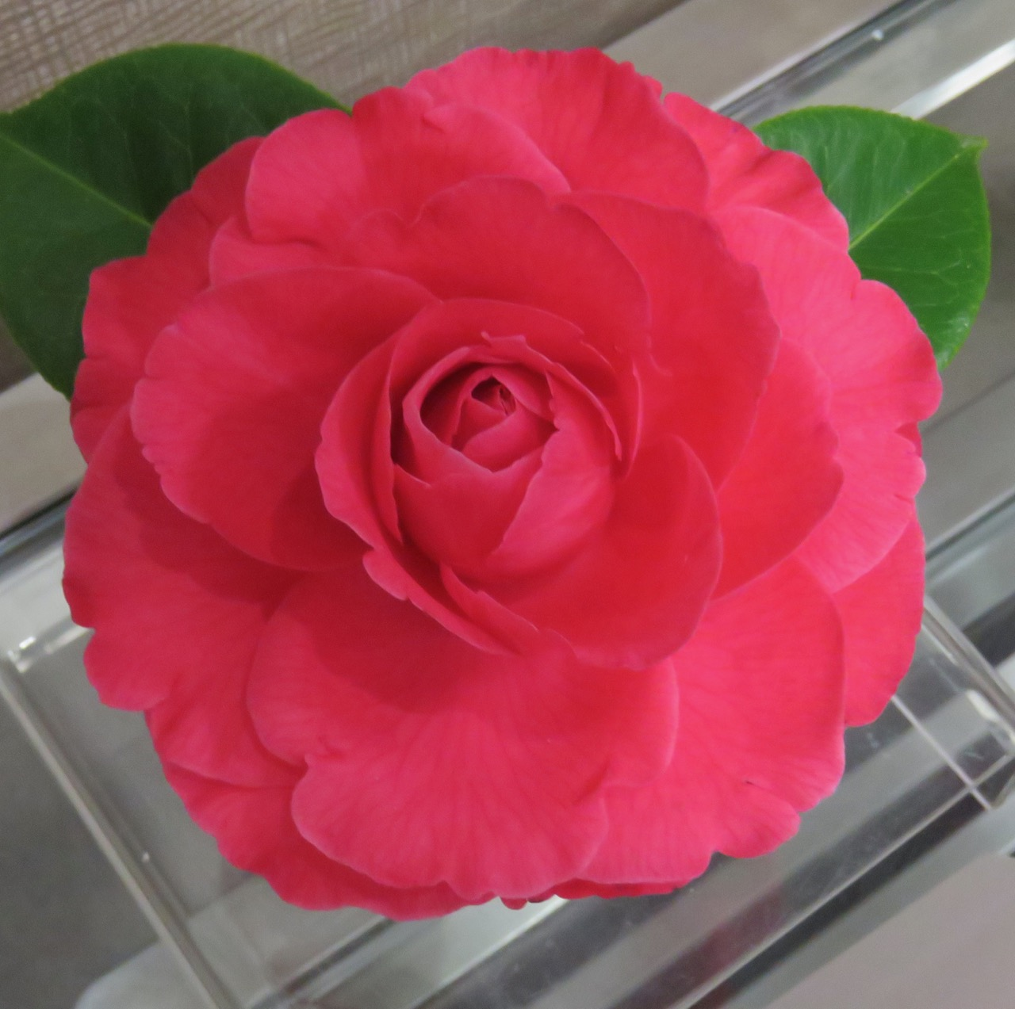
Fold your benching card so that your name is not on display and the card itself is placed just touching the front of the pottle.
Also try and have your pottle as far back as possible on the show bench. This stops your bloom being unintentionally damaged as other members bench their blooms.
Continue through all of your boxes until all your blooms have been entered.
On the morning of the show, check all your entries one more time, if only to ensure that they are the same as when you entered them the night before.
Congratulations! You have now entered a camellia show. You will probably have a feeling of expectation and be curious to see the outcome of the judging. If you have followed the process outlined here, you likely have a good chance of your expectations being met. Even after many years showing, I still enjoy that feeling of expectation each time I enter.

Useful Tips
- With trees in pots, do your final watering 10 days before picking. This won’t be necessary if you have heavy rain within a couple of weeks of the show.
- Once your blooms are all entered into the show, take all your boxes back to your vehicle. This keeps the hall walkways clear and makes space for other people who are entering blooms.
- Never take your freshly picked blooms into a warm dwelling: make your selection in a cold garage or shed. Blooms going straight into a warm house will start to wilt very quickly and will not look good at the show venue.
- Join the New Zealand Camellia Society, if you are not already a member. We have, in my opinion, a very social group of people who are totally dedicated to the genus Camellia and who enjoy one another’s company.

